Information for applicants for the role Independent Panel Member of The Joint Audit Committee

Table of Contents

About the West Midlands Joint Audit Committee 3
Role Profile - Independent Committee Members 4
Purpose of Role 4
Key Responsibilities and Commitments 4
Other Duties: 4
Person Specification 5
Terms of Appointment 7
Appointment Process 7

About the West Midlands Joint Audit Committee

West Midlands Police and Crime Commissioner and West Midlands Police jointly run an Audit Committee which amongst other things advises the Commissioner and Chief Constable about good governance principles, ensures appropriate risk management arrangements and considers internal and external audit reports to both the Commissioner and Chief Constable. In setting up the Joint Audit Committee the Commissioner and Chief Constable have taken due regard of the CIPFA Audit Committees Practical Guidance for Local Authorities and Police as well as the Home Office Financial Management Code of Practice.

The Joint Audit Committee (JAC) comprises of between 5 and 7 independent members, one of whom will undertake the role of Independent Chair and one who will undertake the role of Independent Vice Chair. The West Midlands Police and Crime Commissioned and Chief Constable are currently recruiting Independent Members to join the Chair and Vice Chair on the committee.

We are seeking high calibre candidates who can demonstrate that they are able to meet the requirements of a demanding role, as set out in the role profile. If you have the necessary skills and enthusiasm and can commit yourself to attendance at and preparation for around four meetings a year, we hope that you will apply.

You can read more about the Joint Audit Committee and see the terms of reference on the Police and Crime Commissioner’s website here: https://www.westmidlands-pcc.gov.uk/joint-audit-committee/

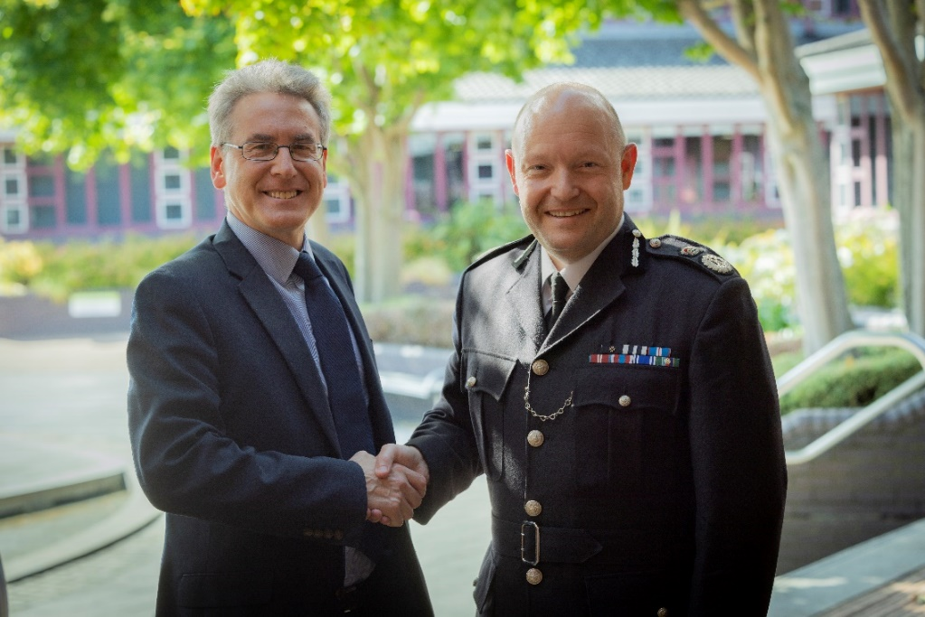

Role Profile - Independent Committee Members

The role of all Independent Members of the Joint Audit Committee is demanding and challenging one. We are looking for high calibre candidates who can provide clear examples demonstrating how they meet as many of the skills, experiences and competencies as possible, as set out below including the role specification.

Purpose of Role
- Contribute as an individual, and collectively within the Joint Audit Committee, to fulfilling the Terms of Reference and adopting and maintaining best practice in doing so.
- Demonstrate a personal commitment to independent thought and challenge in fulfilment of the role and in so doing adopt and present a politically neutral stance.
- Promote the work and role of the Joint Audit Committee within the Police Service wider community.

Key Responsibilities and Commitments
- Attend and constructively participate in all meetings of the Joint Audit Committee.
- Read and consider carefully all reports and documents in preparation for the Joint Audit Committee meetings.
- Prepare suitable questions for senior management with due regard to the role and protocols of the Joint Audit Committee.
- Adopt and demonstrate a politically neutral perspective in questions asked and the general contribution to the work of the Committee whether in formal meetings or elsewhere.
- Apply relevant skills and experience to add value and depth to the work of the Committee.
- Contribute to the development of the Joint Audit Committee members through mutual support and assistance.
- Commit to personal development in the role.

Other Duties:
- Sign and abide by the appropriate Code of Conduct for Members.
- Have due regard for matters relating to health and safety and equality and diversity when undertaking work on behalf of the Police Service at all times and in whatever capacity.
- Conduct yourself adopting the highest levels of personal integrity, openness and honesty following the Standards in Public Life (Nolan Principles).

Further information can be found on the PCC’s website: Job Vacancies - West Midlands Police & Crime Commissioner (westmidlands-pcc.gov.uk)

Person Specification

All Independent Members should be able to demonstrate the following experience, skills and knowledge:
- Detailed experience of operating in a financial environment either within the public or private sector.
- Awareness of current accounting issues.
- Understanding of relevant statutory duties and legislative requirements for Audit Committees.
- Understanding of the principles of risk management.
- Knowledge of modern principles relating to audit, scrutiny and assurance.
- Knowledge and experience of the principles of Corporate Social Responsibility.
- The ability to interpret professional advice and reports.
- Particular experience of ICT or estates/property issues would be desirable.
- Practical management experience in a governance capacity in a large organisation.
- Experience of undertaking representational duties.
- Experience of audit committee work or representation within the private or public sectors.
- Effective analytical skills.
- Effective presentation skills.

Individuals should have, or acquire as soon as possible after appointment, the following in respect of policing:
- Understanding of the objectives and current significant issues for the police service at both a national and local level.
- Understanding of the objectives, responsibilities and current significant issues for the Police and Crime Commissioner.
- Understanding of the West Midlands Police structure.
- Understanding of the various inspection regimes which impact upon the work of the Police Service and the Office of the Police and Crime Commissioner.

Individuals should have and be able to demonstrate the following competencies:
- Integrity, embracing high standards of conduct and ethics.
- Independent thought.
- A constructive but challenging approach.
- A balanced, proportionate approach in preparing and giving advice.
- An ability to frame questions that draw out relevant facts and explanations.
- Enthusiasm and drive.
- Self-confidence.
- Able to demonstrate objectivity
- Respect for others, treating all people fairly.
- Good team working.
- Strong communication, negotiation and influencing.
- Able to promote a professional image at all times.
- Utmost respect for confidentiality.

Individuals should be able to evidence the following education and training attainments, this might contain but is not limited to:
- Qualified CCAB or CIMA accountant.
- Educated to a generally high level.
- Undertaken continuous personal professional and skills development in a relevant area
- Significant personal and lived experience of areas relevant to the role of the Committee

The West Midlands Police and Crime Commissioner understands that to effectively serve an area with such a rich cultural tapestry like the West Midlands, it is vital it is driven by people who reflect the diverse cultures and backgrounds that form its communities.
To achieve this, we are seeking applications from people of all backgrounds and experiences to represent the West Midlands.

Terms of Appointment

Persons appointed as Independent Members to the Joint Audit Committee will not be members of the Commissioner’s or Chief Constable’s staff, nor will they be employees. They will be engaged on a contract for services with detailed terms and conditions which will secure the proper performance of their role in the public interest.

Appointees will be engaged for an initial period of 1 year, which may be subject to extension. The contract for services will be liable for termination by the Commissioner or Chief Constable, at any time with immediate effect without any further payment other than outstanding fees. The contract for services will include a requirement for regular reviews of performance under the contract.

Fees will be paid to Independent Members at the rate of:
- £357 per day and £178.50 per half day)

The Joint Audit Committee is expected to meet around 4 times a year. The time commitment expected of Joint Audit Committee members, will be an average of 4 to 8 days per annum, this includes attendance at meetings, preparation and personal development days required for the role.

Successful applicants will need to be police vetted to NPPV Level 1 due to the confidential nature of information and/or data being considered from time to time.

Attendance at required JAC meetings and associated events will be monitored and failure to attend meetings without good reason may lead to deduction from fees or termination of the contract.

Appointment Process

The selection process will be based upon the principles set out in the Code of Practice published by the Commissioner for Public Appointments which relate to ministerial appointments to public bodies. The three basic principles are that appointments be made on merit by an objective, fair and open selection process. The appointment will be made under the principles of public life set out by the Committee on Standards in Public Life (Nolan Principles).

Applicants are invited to submit a CV and a one page covering letter with references to: wmpcc@westmidlands.police.uk. by the deadline of 12 noon on Thursday 30th May 2024

Interviews will be held in person on Friday 7th June 2024. The interview panel will include:
- Director of Commercial Services, West Midlands Police
- The Chief Finance Officer, The Officer of the Police and Crime Commissioner

For an informal discussion about the role please call Lynn Joyce by emailing: lynn.joyce@westmidlands.police.uk.

